Name:  Teacher: | ____________________________________  ________________ |  | Date:_________
 | Year 11 Mathematics  /40  Mini test  Topic – Measurement  Full working out MUST be shown to get full marks for each question.
Total Time: | 45 minutes | /40
Weighting: | 10 %
Equipment: | To be provided by the student: Pens and Pencils, scientific calculator, A4 page of notes (1 side).

Question 1 5 marks

Suggest an appropriate area unit for measuring:

- the area of a postage stamp

- the area of your desktop

- the area of your bedroom floor

- the area of Tasmania

- the area of a toenail

Question 2 4 marks

Fill in the missing numbers:

km | m | cm | mm
1.2
 |  | 240
 | 890
 |  |  | 1900

Question 3 2, 1, 1 marks

Rugby league players aged 6-8 years old play on a field that is 68m long by 30m wide. During training, each player ran 7 laps around the outside of the field.

- Calculate the distance the players ran in metres

- Convert your answer from part a to kilometres
- Calculate the area of the field

Question 4 2,2 marks

Find the perimeter of the following shapes:

- 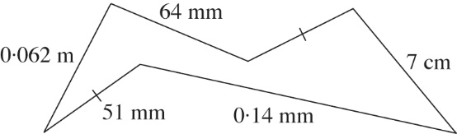

- 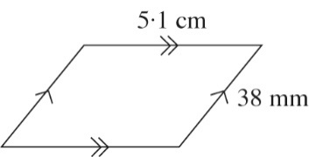

Question 5 2 marks

Find the area of the following shape expressing your answer using the units of:
  - km²
  - m²

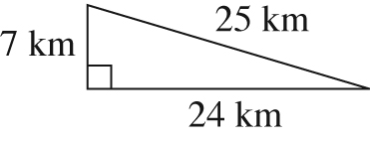

Question 6 2 marks

Mike purchased a 4.2 ha property. Council regulations allow him to have 5 free range chickens for every 100 m². How many free-range chickens is he allowed?

Question 7 3 marks

Find the area of the following shape:
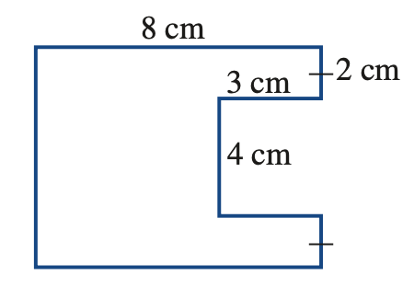

Question 8 2, 1 marks

Jon is having the driveway and path at his new house covered with patterned concrete. The concrete company will charge $65 per square metre. Each square on the plan represents 1 m².
- Estimate the area of the driveway and path.

- Approximately how much will the concrete company charge Jon?

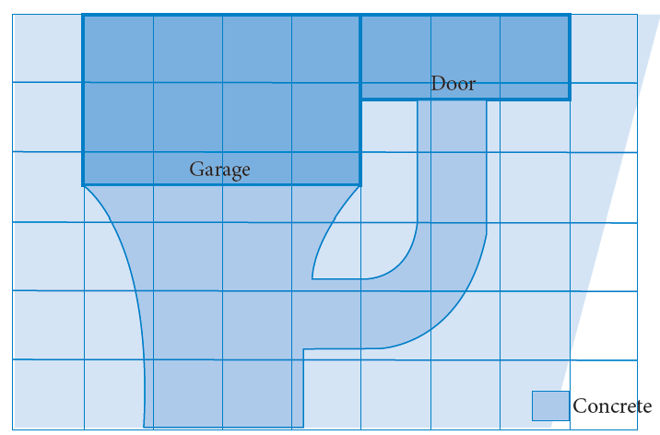

Question 9 3 marks

The solid below is made up of five cubes of side length 4 cm. What is the volume of the solid?

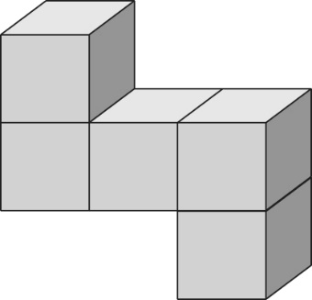

Question 10 3 marks

Find the volume of this triangular-based prism:

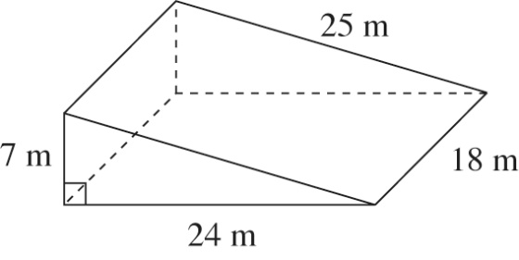

Question 11 2 marks

Sam purchased 2 m² of material. She needs to cut it into rectangles of area 200 cm² for a patchwork quilt. This can be done with no waste. How many rectangles can Sam cut out?

Question 12 1 marks

The capacity of a car engine is quoted as 1800 cc, meaning 1800 cubic centimetres. Write this capacity in litres.

Question 13 3 marks

A shipment of wine is being sent to Europe in 1000 L tanks. Enough wine must be sent so 1000 dozen 750 mL bottles can be filled. How many tanks are needed?

End of Assessment

